-- - · -- - - rn - · I
· 1 ·
QUICK-W RITES: TO ENGAGE, LEARN, AND
'"'" ' ' ;,"'""' - J

Overview
l.Theoretical framework
2. Using quick-writes to:
*
hare connections
.
.
- P{ocess new content
- Reflect qibout clinical experiences
* Apply concepts
- Interaction and engagement
- Formative course evaluation
- Questions
leaching Profesi'orConference. Atlanta, GA: May 30, 2015

Theoretical Foundation
0 Generative nature Of learning (Bruner and Feldman, 1990, Oc.kes & Lipton, 1999)
0 Writing reveals inner workings orthought; what we c1C?td;,m't know (Emjg, 1983; Zinsser, 19.88)) ' ' ' ' ' ' ' ' ' ' ' ' ' '' ' ' ' ' '

0 What .wC? thir\k c\lrrel6tes with. our »>ri ing andwhat we writecorrelc.tes with ol)r thinking (Moshrnan & Franks;.198$1) · ·
0 Writing helps fuel idea evelopment ((Mc.imon, N'odine: & O'Connor, l989)
0. Writing 0cross the content areas ((Fulwiler, 1986, Powell, 1989; McLeod, 1992; Anson et al, 1993; Bazerman ond Russel, 1994)
0 "Low-stakes writing" (Elbow, 1997)

Teachl11g ProfessorConfert-'nce. Allanto, GA: May 30, 2tJ IS

Sharing Connections
Recall a time when ...
"In t/1e Palestinian culture, dire.ct eye
·contact with an .elder is considered rude.
Growinq up; my parents always taught me
When have_yov ever experienced.a cultural "clash".due to different cultural
to lower my gaze wh1l.e speaking to an adult.I had a culture clash ,y first day of
lenses?
·
miC!dle school. M u histoiy teacher was standing at Ille door greeting students as they walkE!d into the class. When Iwalke..d
up to him/1 looked .down as d sign of .· respect. Re }lien said to me,"Make sure you look m!S' .in mY !S'yes. lt'sye1y rud<! to look away when.soEneon.e 1s greeting you:·1 Iwas ve1y confused by h!S remark.
HeartLoroken, Itold my parents whqt had happcmed earlier that day. They explained to me that not all cultures are the same."
Teaching Professor Conference, Atlont<:r, GA: 'Moy 30. 2015

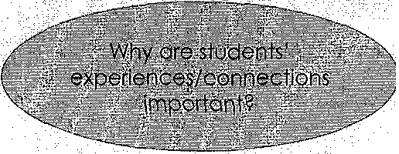

Sharing Connections
Recall a time when . . .
0 Recall a time from your Ol'fn schooling when you felt,especlaJly included, engaged, OfDpreciated, (Jnd;validated i.n the learning pro9ess; ord Recall a .. situa.tion when youfelt especially. excluded,.alienqt"d,.and Invalidated
. fror:i the learning process
"I am aquiet student who doesn' tlike}o mk questions l'fhen I don't undel$tand..1 asually assurnethe teach11r isn 't interested iri talking. tff rne, besides When they're ·
teaching me. Ml freshman year I had an
l'n(JllSh :professorwho required us to.come tq alle¢st one.office hour session. I.was nervous becoi:ise·I had never t.alked to.a professor one oh one •before. He made me fee/really comfortable and asked me
about what Iehjoyed writing, and we just
had a relaxing aonversatfon. That was the fits! time I.saw my professor as a regular person. And the first time I felt seen by a pro'fesSor..."
Teaching ?rofes>orConfernmce. Atlonto. GA: May 30, 20 IS

How dld you learn...?
What do you know about...?
0
How did you learn math? Describe a
positive and a negative learning experience.
"I learned math by memorizing facts and
0
Do you enjoyrnath? Why/why not?
procedures. Inever really understood it.
MY teacher us'f'!dJo make us memorize a
Jot and thatwas hard for someone like me who hos a bpd memory.!don' t think l'm good dt rnoth and it rnokes me. . · nervous that Ihovelateach and plan lessons to teach kids rhdlh..."
TeochingProfesmrCon!erence, Allon!o, GA: May 30, 2015

Reflection of clinical e(<perienc e
0 What did you learn dl)out your students'
attitudes towards math? Knowledge/skills?
0 How will this knowledge ln l.uence how you teach nexl'we'!>k?· ·
' The students cis a whole seemed negative
towards math and said, "!f's not funl" By the end of the le.sson they all werl;! · answering questions pnd partidpating. They <:i,Ven s9id they had fun and look fqrvy<Jrd to nexttime! This knowledge will ihfluence our ti?,dchlng by. approqchinQ it w.lth funq.ctivities thpt invole everyone; Also, we wlll makesure our @roup f ully understancts the qanc;.ept before moving
on, Try to bu/ld cohfideric'3! ond usepositlve reirjfOrcement to help them more · comfortoble [sic] in the learning·
environment,,, II
'
EDMS 4121: Dr. Noelle Won

Refl.ectron of clinical experience
Quick-Write Reflectiop:
How has increased "Wait time" affected your students?
What other Talk Moves have you tried, and how.Were they effective?
What have you be.en IEiarning from teaching Math Masters?
"Idefinitely practieed to ihcre.ase
response wait-time today.during my lesson, Each time I asked.a question, I let them know to think about their answer before we shored !heir answers with the whole c/oss, '· noticed that their responses were more elabordte .anq ttieywere able to formuldte .aresponse ()sing complete.thoughts and sentences instead of one word answers,,."
fooching ProfesmrConference, Atl6nto, GA: Moy:10, 2015'

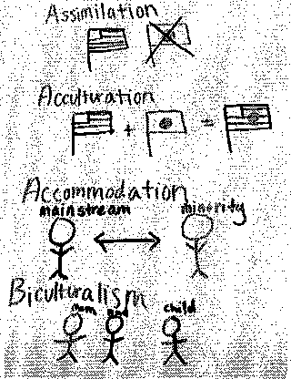

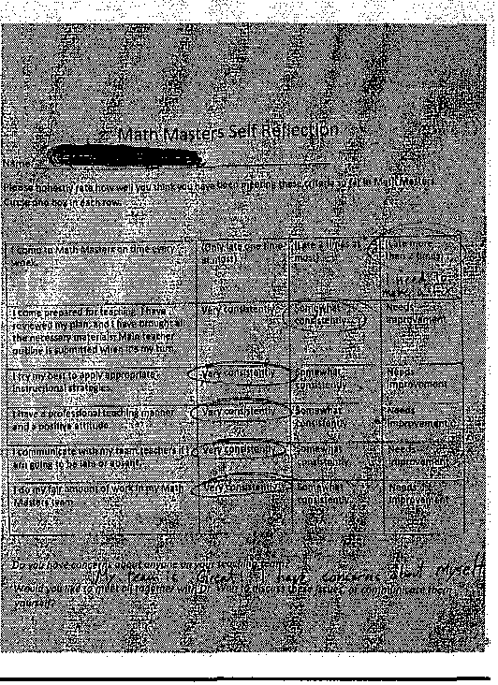

Self-reflection of clinical experience

ence:Atlopta, Gk Moy 30, 2015

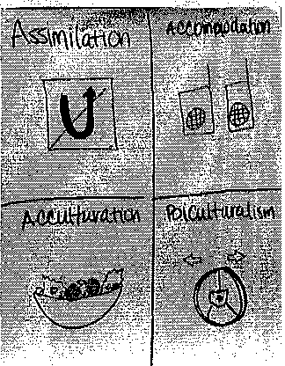

Process n.ew. content: Visual
Cred e Ci visual for eac/I of these terms,
.and prov de an example,·

Assimilation Acculturation Hybridization

leaching ProfesmrConference, Allonto, GA: <ly 30. 201,5

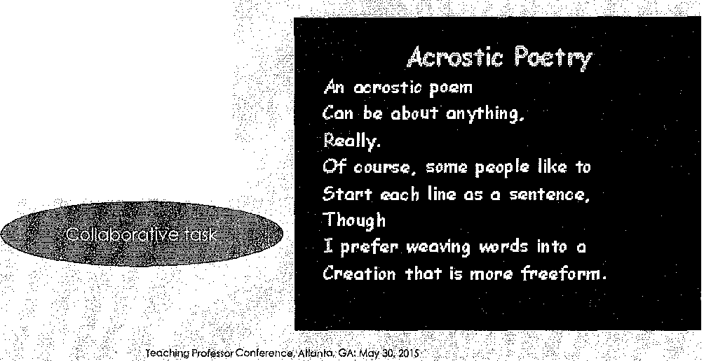

Creativesy:nthesis of content
0 Think of an a!$rony:mJor your topit:: Write it verticbll)' ih l?rge;bole) lettero.
0 Write a phrase tl\atbegins ;vith each letter o.f your wore), cmd. adds an important detqil a.bout your topic. Write these horizontally from each letter.

II
Graphic·organizerto proqess
content
·
· · ·· ··
-
RE!adlnq .To. With, and By Ells
l.
2.
3:
4,
· 5.
Reaci-alouds 'Dr. Won
Shbred reading Guided r$ading EA
Independent reading .
P,repare a graphic organizer of
your assigned acti\iity. (Think .
paiN.hare). •
·
o. Purpose
. ..
- How do you do ii (B;(ore,
Dutlrig, After1
- H.ow can you.support ELLs
- What should teacllers keep In mind

WJ\;100\tlll  •k!wJW? | 8rain<tormw;iyifo folv.!lhj•p.'Obl'"1i
-< :::::' .>---
tl<plm!iom)'OU
rolndudolnr<V
9•-0<pl)ll• wrh.up.
\\h,.did)'OUlwnby<klf119
U11•prllbloml

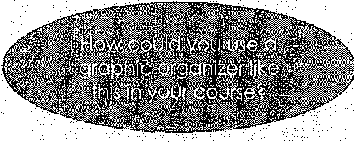

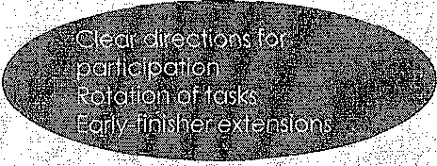
Collaborative quick-writes to apply
concepts
Sh<lrina and·debrief .

Eac.h gr6upwill share their resl'.)anses to ONE of the .tdsks, with clear rationale.
Tbe rest af th class will pr<Dvide
0 Each group needs to have atleas.t 4 aodltlonal comments/questions . people, and.ho more thans,
0 Write everyone's names on top al the quick-write,
0 You will have 20 minutes to complete each quick-write.
0 After you complete the quick-write, submit your paper into the folder at the table. ·
Teachlrig ProfesiorCOnference. Atlanta, GA:.May'30, 2015

"

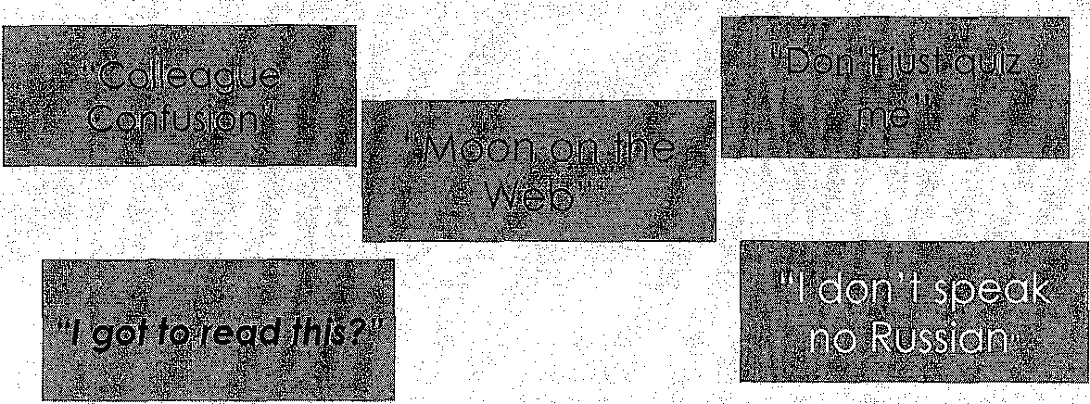

Group quick-writes
Today you will work in a group to complete 5 tasks:

Create scenarios for app.lication
"Colleage Confslon"
Your bilingual tea¢her collague really wants to help a s\lJd.ent.who recently• .· emigratedJrdmMelco,.and tylls you she is going to dJrectly translateevery leson, an.d orally translate all the reqdings•into.Spanish, What wo.uld you tell her pboiJJthis type .of Llsuppqrt? W.hat other SLIQgestions would.
SAMPLE
you provide? •·• · · • •.

Write your response on the note cqrd.
0 This will be a role play dialogue. I will randomly call on pne group to perform.
TeQching ProfessorConleren¢e. A tionto. GA: May.. 2015

Quick-table write

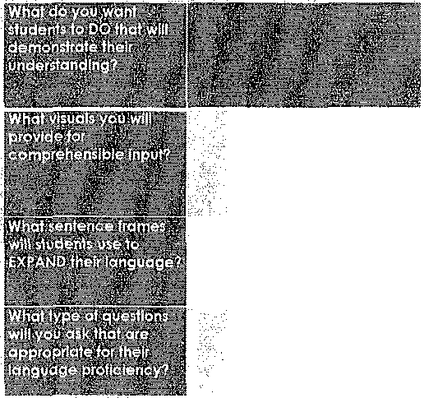Describe an assessment that would clearly address this 1 grade.math objective, with Expanding/Bridgi ng ELLs In mind (Tier 1).
Students will be able to partition circles irito two _and foµr,·equaLshar'es, describe the shres using the phrases half of,jourth of, and
quarter of · ·.
. .
***BohUs: Ho_W_-_Y()_u·Yr\i9ht ada·pt thi_s·:assessment
for o. Emere1'ng student who just arrivedinthe u..s.:3 montfrs agO, (Trer 3)?How would yqy provide increasd support for this student?
How coul<j your questions change?Wouldyou look for something dif.ferent to demons.trate their--undersanding of this sam oj_ective?

TP.aching Professor Conferende. Atlon!o, GA: Moy 30, 2015

Quickwrif es for exploration and
analysis
0 Explore this webquest andwrite three
ways it would enhance El s' comprehension of the science concept; and/or three w(Jys the teacher woulclneed to suppoi:t El s use and. comprehension of ti'lis
ebquest.
SAMPLE
Teaching Professor Conference, Atlanta,. GA: Moy 30, :?Ql5
•7

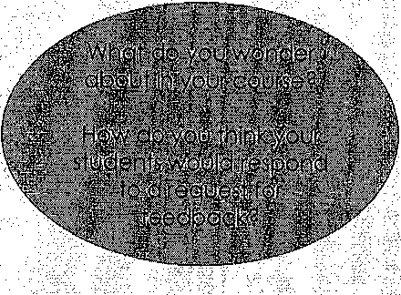

Studenl feedback
I appreciate yourresponses,Qs this is the first time I am trying out the aiscussion board, and I don 'iknow If I like i.
0 Do you have any suggestions to improve the discussion.board?

0 Wovld you 'prefer to bring your•.typed response to. theweekly discussion board question:ano discuss lace-to­
face in groups quring class? (we could . also do this evE>fY other.week.) ··

Teaching Prole;sor_Conference, Alionlo, GA: Moy 30, 2015

.· .

Formative course evaluation
I'mInterested In your feedback on how t:he.c1a's'i1 going. Ple'ase take c 'tew ·
minutes to provide your commenls, ReSpOnSe to stu·dent needs:

The amount of content Is: :.Too much Too little
_ Just right l) Assignments need tO be more explicitly addressed

The pace of the course is: _ Too lost
Too slow
_ Just right
and liriked to course readings.

How well do you understand the course content so far?
_ Very well _ Adequately Totally lost
Do the assignments helpyou process/opp]ythe course content/readings?
_ Very well _ Adequately Not at all
g, B dl Wes he!p you l'oCess/(lPply the courSe
_ Ver}r well _-Adequatl\i_ly Not at oll
Do you think Particlpotl- In Mih,Mate- Is a worthwhi1e:aspec1 of this course'?
- Slow down pace arid reduce ccinten!

- Give lq.·miriutes ·after Math.Masters tb dEibrief w.ith.
teaching .Partners.

5 4
(most defini1ely)
3 2
(nofreolly)

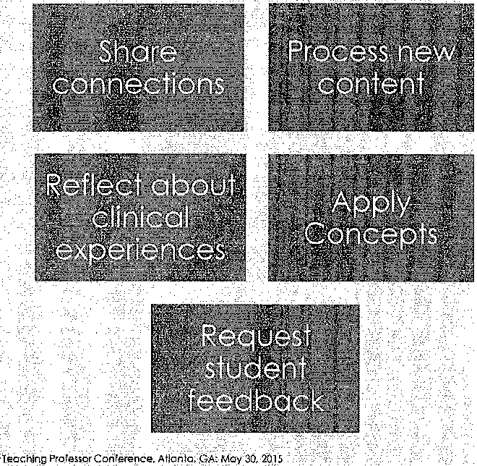Comrryen!J; (What do you like sO far'?'-Anythlngyou n9ed'more helpwith\!)

Teaching Profes>or<:onlerenee. Atl'on,to. GA: May 30)1015 19

Quick-writes

20

Noelle Won
Associate Professor Department of Tea2het Ed.uca.tion California State University StanisJous
.
.
'Teaching ProFE.sso Conference,Atlonta,°'GA: May 30, 20 l5 '

